Loosely Coupled Microservices and API Gateways
You have an awesome idea and you've built a cool application. Like any entrepreneur or developer, you really hope that your app will go viral and lots of users will want to use your app. Or maybe your enterprise has a business critical application that must be highly available and handle millions of transactions reliably.
In the module Best Practices for Application Development, you'll learn design and development techniques to develop applications that are secure, scalable, resilient and highly available. Here are some key areas we'll discuss.
- Implement Microservices-based architectures with loosely coupled services that can be monitored and can fail gracefully on error. Consider issues such as compliance with local laws and user latency when deciding where to deploy your infrastructure.
- Be sure to implement build and release systems that enable continuous integration and delivery. While it's crucial that you have repeatable deployments, it's also important that you have the ability to roll back to a previous version of the app in a few minutes if you catch a bug in production.
- Finally, your journey to the Cloud is not an all-or-none scenario. Depending on your organization's maturity and comfort level with the Cloud, you can re-architect and migrate legacy applications in an incremental manner. In the module, we'll discuss all these areas and more.
Applications that run in the Cloud must be built for global reach, scalability and high availability and security. Your application should be responsive and accessible to users across the world. Your application should be able to handle high traffic volumes reliably.
The application architecture should leverage the capabilities of the underlying cloud platform to scale elastically in response to changes in load.
Your application and the underlying infrastructure should implement security best practices.
Depending on the use case, you might be required to isolate your user data in a specific region for security and compliance.
In this presentation, you learn best practices related to
- Code and Environment Management,
- Design and Development, Scalability and Reliability, and Migration.
Let's start with managing your application's code and environment. Store your application's code in a Code Repository, such as Git or Subversion. This will enable you to track changes to your source code and set up systems for continuous integration and delivery. Don't store external dependency such as jar files or external packages in your code repository. Instead, depending on your application platform, explicitly declare your dependencies with their versions, and install them using a dependency manager. For example, for a Node.js application, you can declare your application dependencies in a package.json file, and later install them using the NPM install command. Separate your application's configuration settings from your code. Don't store configuration settings as constants in your source code. Instead, specify configuration settings as environment variables. This enables you to easily modify settings between development test and production environments. Instead of implementing a monolithic application, consider implementing or refactoring your application as a set of microservices. In a monolithic application, the code base becomes bloated over time. It can be difficult to determine where code needs to be changed. Packages or components of the application can have tangled dependencies. For example, in this monolithic application, the UI, order, payment, shipping, and other components are all part of a single large code base. The entire application needs to be deployed and tested even if a change is made to a small part of the code base. This increases the effort and risk when making future changes and bug fixes.
Microservices enable you to structure your application components in relation to your business boundaries.
In this example, the UI, payment, shipping, and other services are all broken up into individual microservices. The code base for each service is modular. It's easy to determine where code needs to be changed. Each service can be updated and deployed independently without requiring the consumers to change simultaneously. Each service can be scaled independently depending on load. Make sure to evaluate the costs and benefits of optimizing and converting a monolithic application into one that uses a microservices architecture.
Remote operations can have unpredictable response times and can make your application seem slower. Keep the operations and the user thread at minimum.
Perform back-end operations asynchronously. Use event driven processing where possible. For example, if your application processes images that are uploaded by a user, you can use a Google Cloud Storage bucket to store the uploaded images. You can then implement Google Cloud Functions that are triggered whenever a new image is uploaded. Cloud Functions can process the image and upload the results to a different Cloud Storage location.
Design application components so that they are loosely coupled at one time. Tightly coupled components can make an application less resilient to failures, spikes in traffic, and changes to services.
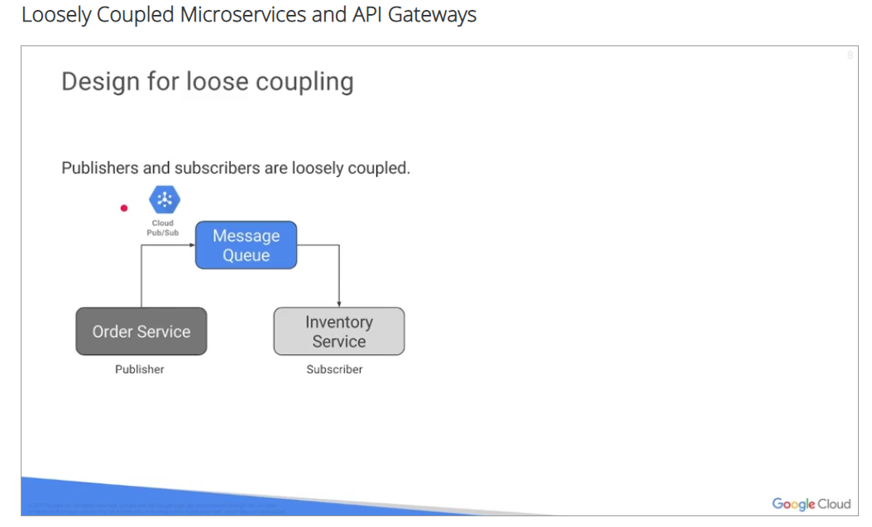An intermediate component such as a message queue can be used to implement loose coupling, perform asynchronous processing, and buffer requests in case of spikes in traffic. You can use a cloud pop subtopic as a message queue. Publishers can publish messages to the topic, and subscribers can subscribe to messages from this topic.
In the context of HTTP API payloads, consumers of HTTP APIs should bind loosely with the publishers of the API. In the example, the email servers retrieves information about each customer from the customer service. The customer service returns the customer's name, age, and email address and its payload. To send an email, the email service should only reference the name and email fields of the payload. It should not attempt to bind with all the fields in the payload. This method of loosely binding fields will enable the publisher to evolve the API and add fields to the payload in a backwards compatible manner.
Implement application component so that they don't store state internally or access a shared state. Accessing a shared state is a common bottleneck for scalability. Design each application so that it focuses on compute tasks only. This approach enables you to use a worker pattern, to add or remove additional instances of the component for scalability. Application components should start up quickly to enable efficient scaling, and shut down gracefully when they receive a termination signal. For example, if your application needs to process streaming data from IoT devices, you can use a Google Cloud pop subtopic to receive the data. You can then implement Google Cloud functions that are triggered whenever a new piece of data comes in. The Google Cloud Function can process, transform, and store the data. Alternatively, your application can subscribe to the pop subtopic that receives the streaming data. Multiple instances of your application can spin up and process the messages in the topic, and split the workload. These instances can automatically be shut down when there are very few messages to process. To enable elastic scaling, you can use any compute environments such as Google Compute Engine with Google Cloud Load Balancing, Google Container Engine, or Google App Engine. With either approach, you don't have to develop code to manage concurrency or scaling. Your application scales automatically depending on the workload. So you're performing asynchronous operations and your database queries are doing well.
But your application still seems a bit slow. What can you do?
Cache-ing content can improve application performance and lower network latency. Cache application data that is frequently accessed or that is computationally intensive to calculate each time. When a user requests data, the application component should check the cache first. If data exists in the cache, meaning the TTL has not expired. The application should return the previously cached data. If the data does not exist in the cache or has expired, the application should retrieve the data from back-end data sources, and re-compute results as needed. The application should also update the cache with the new value. In addition to cache-ing application data in a cache such as Memcached or Redis, you can also use a content delivery network to cache webpages. Cloud Content Delivery network can cache load balanced front-end content that comes from compute engine VM instance groups, or static content that is served from Cloud Storage. For more information about using cloud CDN, see the downloads and resources page.
Implement API gateways to make back-end functionality available to consumer applications. Here's an example of an ordinary API deployed on Cloud endpoints. You can use Google Cloud endpoints to develop, deploy, protect and monitor APIs based on the open APIs specification or GRPC.
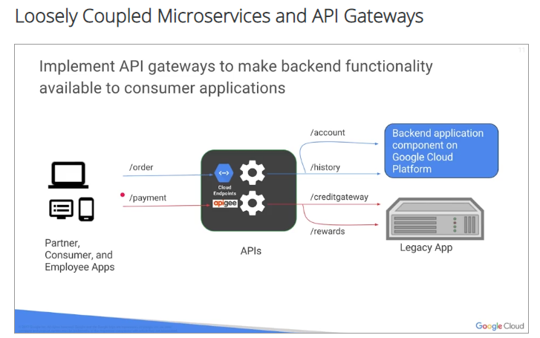
Further, the API for your application can run on back-end :
1, such as Google App engine, Google Container Engine, or Google Compute Engine.
2, If you have legacy applications that cannot be re-factored and move to the Cloud, consider implementing APIs as a facade or adapter link.
Each consumer can then invoke these modern APIs to retrieve information from the back-end, instead of implementing functionality to communicate using outdated protocols and desperate interfaces. Here's an example of a payment API deployed on RPG. Using the RPG API platform, you can design, secure, analyze, and scale your APIs for legacy back-ends. For more information about the RPG API platform, see the downloads and resources page.

Security, Reliability, and Migration

Why build your own system for user management if you can use federated identity management? Delegate user authentication to external identity providers such as Google, Facebook, Twitter, or GitHub.
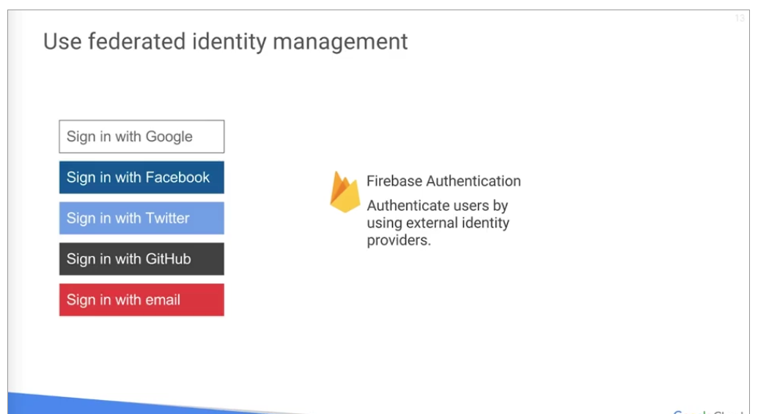
This will minimize your effort for user administration. With federated identity management,
you don't need to implement, secure, and scale a proprietary solution for authenticating users.
CHECK THE BEST PRACTICES:
https://cloud.google.com/blog/products/gcp/12-best-practices-for-user-account
It's important to monitor the status of your application and services to ensure that they're always
available and performing optimally.
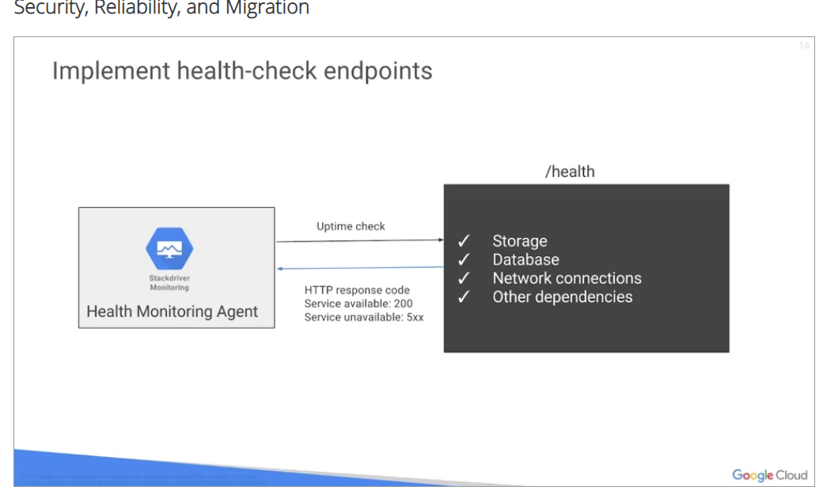
The monitoring data can be used to automatically alert operations teams as soon as a system begins to fail. Operations teams can then diagnose and address the issue promptly, implement a health check endpoint for each service. The endpoint handler should check the health of all dependencies and infrastructure components required for the service to function properly. For example, the endpoint handler can check the performance and availability of storage, database, and network connections required by the service. The endpoint should return an HTTP response code of 200 for a successful health check. If the health check fails, the endpoint handler can return 503 or a more specific response call, depending on the error.
Evaluate which dependencies are critical enough to result in a health check failure. For example, consider a UI service that displays recommendations in one section of the web page. The UI is designed to degrade gracefully, meaning hide the recommendations section if the recommendations engine is down.
With this design, if the recommendations engine fails, you can report the failure on the health status web page, but still return a successful health check for the UI service. This approach ensures that your application continues to receive traffic, even if some noncritical dependencies are unavailable. A Health Monitoring Agent, such as a load balancer or stock travel monitoring, can periodically send requests to the health check endpoint.
Load balancers use health checks to determine if an application instance is healthy and is capable of receiving traffic. If the health check fails beyond the threshold that you've defined, Stackdriver Monitoring can send you an alert automatically. Set up logging and monitor your application's performance. Treat your logs as event streams. Logs constitute a continuous stream of events that keep occurring as long as the application is running.
Don't manage log files in your application. Instead, write to an event stream, such as standard out, and let the underlying infrastructure collate all events for later analysis and storage. With this approach, you can set up logs-based metrics and trace requests across different services in your application.
With Google Stackdriver, you can debug your application, set up error monitoring, set up logging and logs-based metrics, trace requests across services, and monitor applications running in a multi-cloud environment. When accessing services and resources in a distributed system, applications need to be resilient to temporary and long-lasting errors.
Resources can sometimes become unavailable due to transient network errors. In this case, applications should implement retry logic with exponential backoff and fail gracefully if the errors persist.
The Google Cloud Client Libraries retry fail requests automatically. When errors are more long-lasting, the application should not waste CPU cycles attempting to retry the request over and over again. In this case, applications should implement a circuit breaker and handle the failure gracefully.
For errors that are propagated back to the user, consider degrading the application gracefully instead of
explicitly displaying the error message. For example, if the recommendations engine is down, consider hiding the product recommendations area on the page instead of displaying error messages every time the page is displayed. Consider data sovereignty and compliance requirements. Some regions and industry segments have strict compliance requirements for data protection and consumer privacy. For example, European Union's data protection directive regulates the processing of personal data.
The directive specifies a number of requirements that companies must meet around protecting personal data. Review the data protection requirements for the industry segments, and the regions where your users and services will be located. For more information about security and compliance in Google Cloud Platform, see the downloads and resources pane. In addition to executing functional and performance tests, execute high availability testing as well. Such testing will enable you to develop robust disaster recovery plans and perform disaster recovery practice exercises regularly.
Identify failure scenarios and create disaster recovery plans that identify people, processes, and tools for disaster recovery. Initially, you can perform tabletop tests. These are tests in which teams discuss how they would respond in failure scenarios, but don't perform any real actions. This type of test
encourages teams to discuss what they would do in unexpected situations. Then simulate failures in
your test environment. After you understand the behavior of your application under failure scenarios, address any problems and refine your disaster recovery plan, then test the failure scenarios in your production environment.
You can perform Canary testing or blue-green deployments on your production environment. Consider scheduling such testing during a maintenance window or during off-peak hours to minimize impact. Consider failure scenarios such as connectivity problems, on-premise data center, or other cloud-provider failure, GCP zonal, or regional failure.
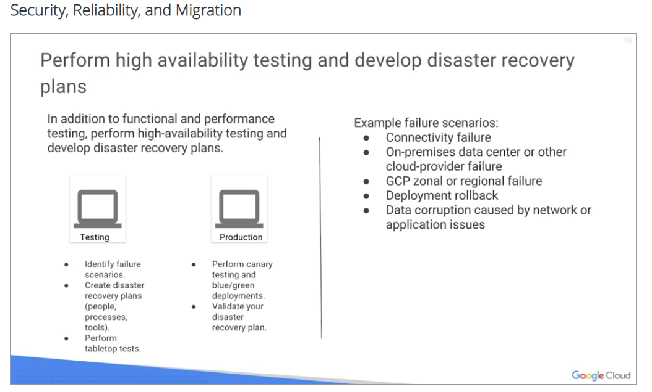
Zonal failures are uncommon and regional failures are extremely rare. Also consider scenarios such
as deployment rollbacks. In some cases, you might have to rollback a software deployment to an older stable version. Test the rollback procedure.
Also test, check for data corruption caused by network or application issues. It's important to have a process to restore data from backups in case of data corruption caused by network or application issues. In each of these failure scenarios, make sure that the appropriate people were notified about the failure in a timely manner and that traffic was rerouted, using redundant routes. Make sure data was not corrupted during the failure or recovery process and that all services were restored in a timely manner.
Implement a strong DevOps model with automation to enable continuous integration and delivery, or CI/CD.
Automation helps you increase release velocity and reliability. With a robust CI/CD pipeline, you can test and roll out changes incrementally instead of making big releases with multiple changes. This approach enables you to lower the risk of regressions, debug issues quickly, and rollback to the last table build, if necessary.
In a continuous integration system, developers commit code into a code repository such as Git.
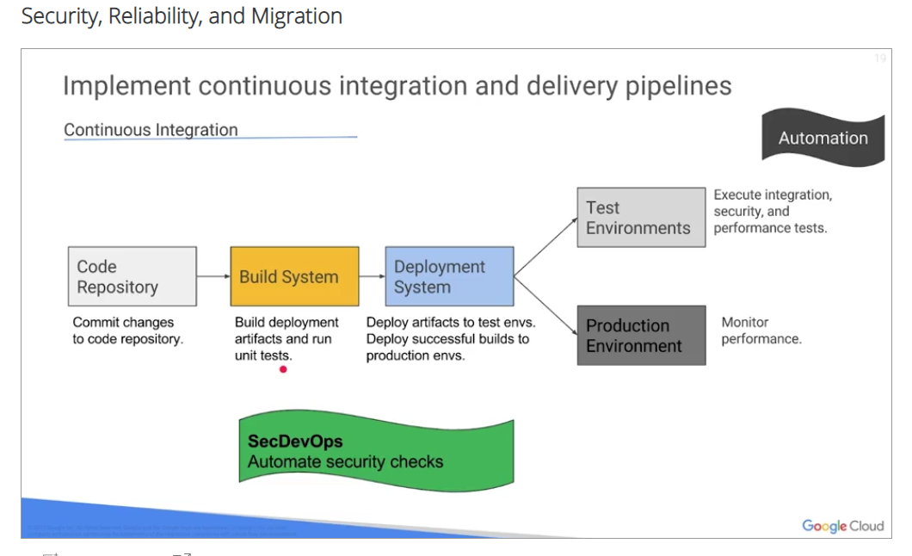
A build system such as Jenkins automatically detects, commits to the repository, triggers builds, and runs unit tests. The build system produces deployment artifacts for all required runtime environments. In a continuous delivery system, a deployment system such as Spinnaker automatically triggers the deployment of bills to test environments. You can automatically execute integrations, security, and performance tests, and then deploy successful bills to your production environment. When rolling out bills to the production environment, consider performing Canary testing or blue-green deployments to make sure that any unexpected issues do not affect a large number of users.
You can set up performance metrics and alerts to monitor the applications performance and production. It's important to consider security throughout the continuous integration and delivery process. With a SecDevOps approach, you can automate security checks such as confirming whether you're using the most secure versions of third-party software independencies. You're scanning code for security vulnerabilities, confirming that resources have permissions based on principle of lease privilege, and detecting errors in production, and rolling back to the last table built.
If you have a large code base of legacy applications, don't worry about your journey to the cloud.
Consider using the strangler pattern when re-architecting and migrating large applications. In the early phases of migration, you might replace smaller components of the legacy application with newer
application components or services. You can incrementally replace more features of the original application with new services. A strangler facade can receive request and direct them to the old application or new services. As your implementation evolves, the legacy application is strangled by new services and is no longer required.
This approach minimizes risk by enabling you to learn from each service implementation without
affecting business critical operations.
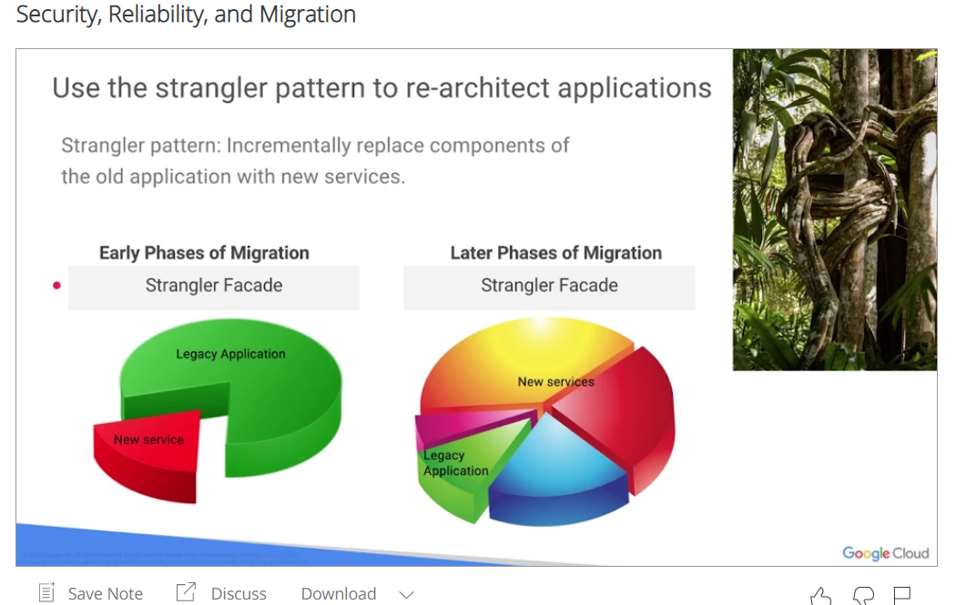
The term strangler comes from strangler vines, the vine seed, and start growing on the upper branches of fig trees, gradually envelop the tree, and finally kill the tree that acted as their host.
Use the strangler pattern to re-architect applications.

Summary:
Design, develop, and deploy your application with global reach, security, scalability, and high availability in mind. Use a code repository for source control, a package manager to manage dependencies, and a CI/CD pipeline to release your application.
In the design battle, microservices went over monolithic applications. Loosely coupled microservices,
asynchronous operations, stateless components, and caching. These implementation choices can really
help you build a highly scalable and reliable application.
And remember, if you have a huge code base of legacy applications, you can take your time to re-architect them and move them to the cloud. Use the strangler pattern.

Quiz:

1. Question 1
You need to design a social application to reach a much broader audience than before. You want to achieve scalability, reliability, and security. Select two best practices that you can implement to build scalable, more secure, and highly available applications?
Manage your application’s code and environment by using a code repository and a dependency management system.
Design for loose coupling between application components.
Avoid caching to minimize the number of services that your application depends on.
Develop a highly secure user management system that you can rely on.
Question 2

2. Question 2
You have a mission-critical application that is accessed globally. You must make sure that your application is able to serve traffic reliably. What is the best way to check if your application is ready to serve traffic?
Ask your testing team to run the system tests every day.
Write a cron job to ping your application's home page every minute.
Implement a health-check endpoint for each service.
Set up monitoring dashboards that your global support team can look at 24 x 7.
Question 3

3. Question 3
Which of the following statements is true?
You can review data compliance and sovereignty requirements after you see the source of user traffic at launch.
It is better to re-architect legacy applications in one big release so that engineering teams can focus on new applications.
For transient network errors, applications should implement retry logic with exponential backoff and fail gracefully if the errors persist.
When rolling out builds to the production environment, consider performing canary testing to catch any Easter eggs (hidden messages and jokes) that developers may have hidden in the code.

